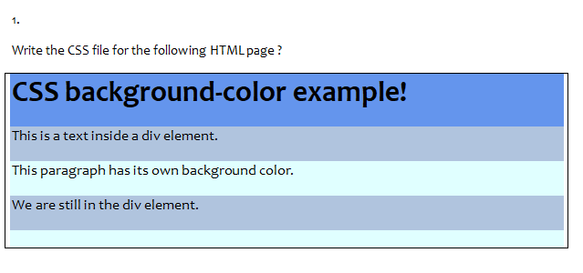

<html>

    <head>

        <link rel="stylesheet" href="style7.css">

    </head>

    <body>

            <div class="a">

                <p>CSS background-color example!</p>

            </div>

            <div class="b">

                <p>This is a text inside a div element.</p>

            </div>

            <div class="c">

                <p>This paragraph has its own background colour.</p>

            </div>

            <div class="d">

                <p>We are still in the div element.</p>

            </div>

    </body>

</html>

.a

{

    width:1300px;

    height:56px;

    font-size: 30px;

    font-weight: bold;

    background-color: blue;

}

.b

{

    width:1300px;

    height:56px;

    display:inline-block;

    background-color:grey;

}

.c

{

    width:1300px;

    height:56px;

    display:inline-block;

    background-color:lightblue;

}

.d

{

    width:1300px;

    height:56px;

    display:inline-block;

    background-color:grey;

}

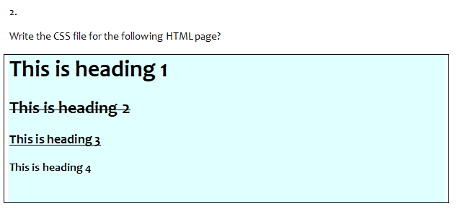

<html>

    <head>

        <link rel="stylesheet" href="/style1.css">

    </head>

    <div class="d">

    <body>

        <h1>This is heading 1</h1>

        <h2>This is heading 2</h2>

        <h4>This is heading 3</h4>

        <h5>This is heading 4</h5>

    </body>

</div>

</html>

h2

{

    text-decoration-line:line-through;

}

h4

{

    text-decoration-line:underline;

}

div.d

{

    border: 1px solid black;

    background-color: lightblue;

}

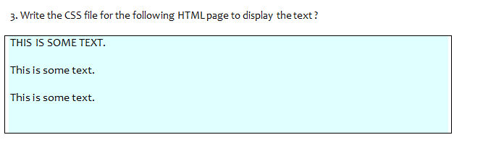

<html>

    <head>

        <link rel="stylesheet" href="/style2.css">

    </head>

    <body>

    <div class="a">

        THIS IS SOME TEXT.<br>

        This is some text.<br>

        This is some text.<br>

    </div>

    </body>

</html>

div.a

{

    border: 1px solid black;

    background-color: lightblue;

    line-height: 200%;

}

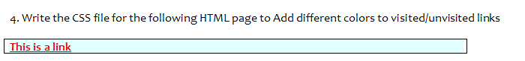

<html>

    <head>

        <link rel="stylesheet" href="/style.css">

    </head>

    <body>

        <div class="b">

        <a href="https://www.youtube.com/">This is a link</a>

        </div>

    </body>

</html>

div.b

{

    border: 1px solid black;

    background-color: lightblue;

    color: red;

}

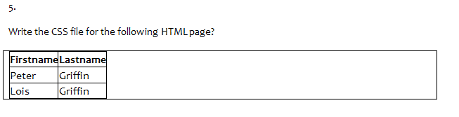

<html>

    <head>

        <link rel="stylesheet" href="/style3.css">

    </head>

    <body>

        <div class="a">

        <table>

            <tr>

                <th>FirstName</th>

                <th>LastName</th>

            </tr>

            <tr>

                <td>Peter</td>

                <td>Griffin</td>

            </tr>

            <tr>

                <td>Lois</td>

                <td>Griffin</td>

            </tr>

        </table>

    </div>

    </body>

</html>

div.a,td,th

{

    border: 1px solid black;

}

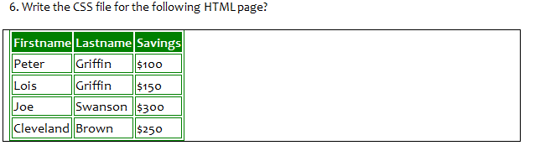

<html>

    <head>

        <link rel="stylesheet" href="/style4.css">

    </head>

    <body>

        <div class="a">

        <table>

            <tr>

                <th>FirstName</th>

                <th>LastName</th>

                <th>Savings</th>

            </tr>

            <tr>

                <td>Peter</td>

                <td>Griffin</td>

                <td>$100</td>

            </tr>

            <tr>

                <td>Lois</td>

                <td>Griffin</td>

                <td>$150</td>

            </tr>

            <tr>

                <td>Joe</td>

                <td>Swanson</td>

                <td>$300</td>

            </tr>

            <tr>

                <td>Cleveland</td>

                <td>Brown</td>

                <td>$250</td>

            </tr>

        </table>

    </div>

    </body>

</html>

div.a

{

    border: 1px solid black;

}

tr{

    border: 1px solid green;

}

th,td{

    border: 1px solid green;

}

th{

    background-color: green;

}

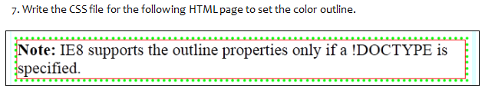

<html>

    <head>

        <link rel="stylesheet" href="/style5.css">

    </head>

    <body>

        <div class="a">

        <p><b>Note:</b> IE8 supports the outline properties only if a !DOCTYPE is specified.</p>

        </div>

    </body>

</html>

div.a

{

    border: 1px solid orange;

    outline-style: dotted;

    outline-color:  green;

    font-size: 20px;

}

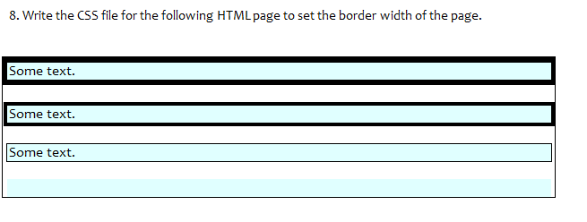

<html>

    <head>

        <link rel="stylesheet" href="/style2.css">

    </head>

    <body>

    <div class="a">

        THIS IS SOME TEXT.<br>

        This is some text.<br>

        This is some text.<br>

    </div>

    </body>

</html>

div.a

{

    border: 1px solid black;

    background-color: lightblue;

    line-height: 200%;

}